CLOUD COMPUTING LAB: WEEK 8

PES1201802127

Siddharth K Rao

1. **Task 1: Create a Kubernetes cluster using minikube**

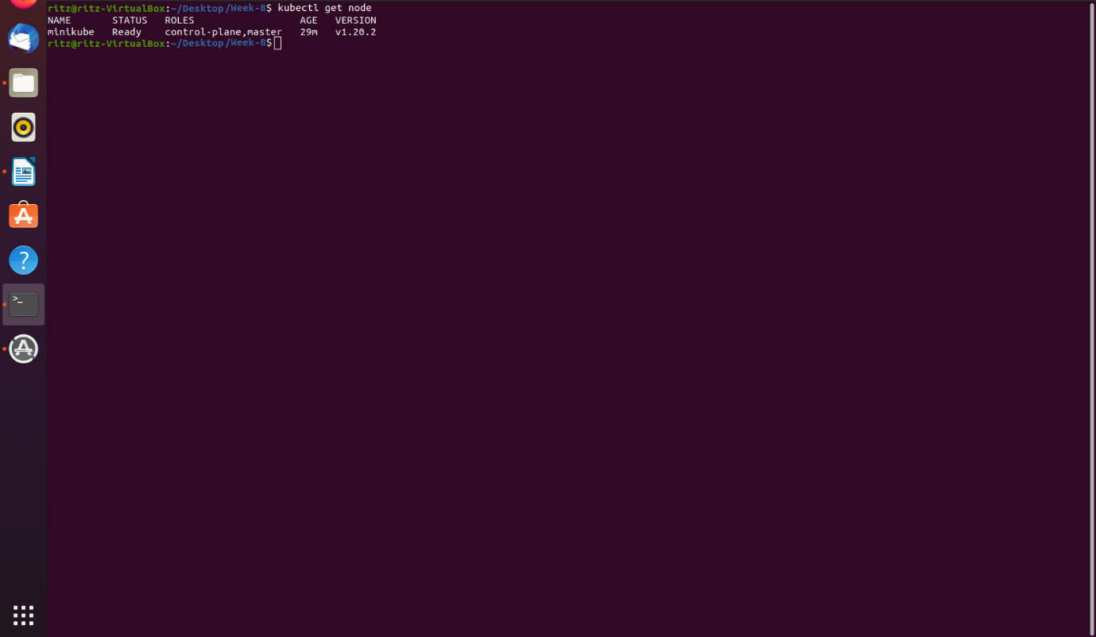

**1a.png**

2.) **Task 2: Create a Kubernetes pod**

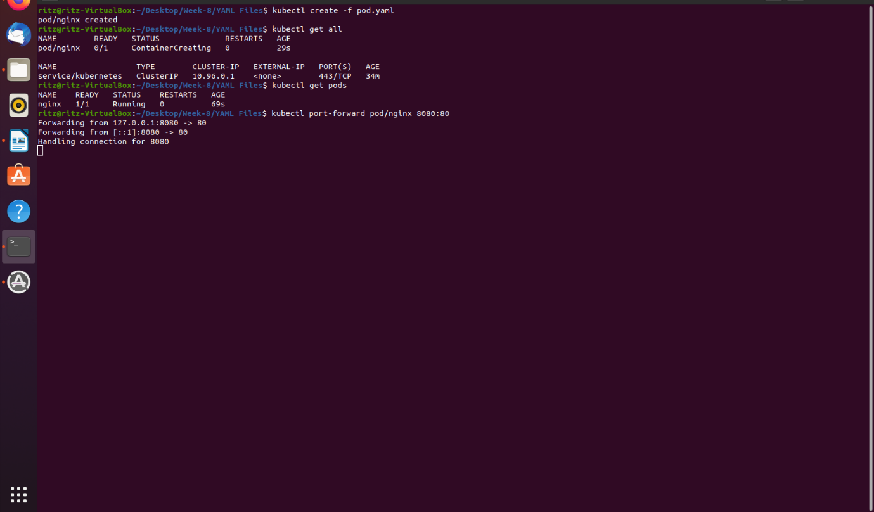

**2a.png**

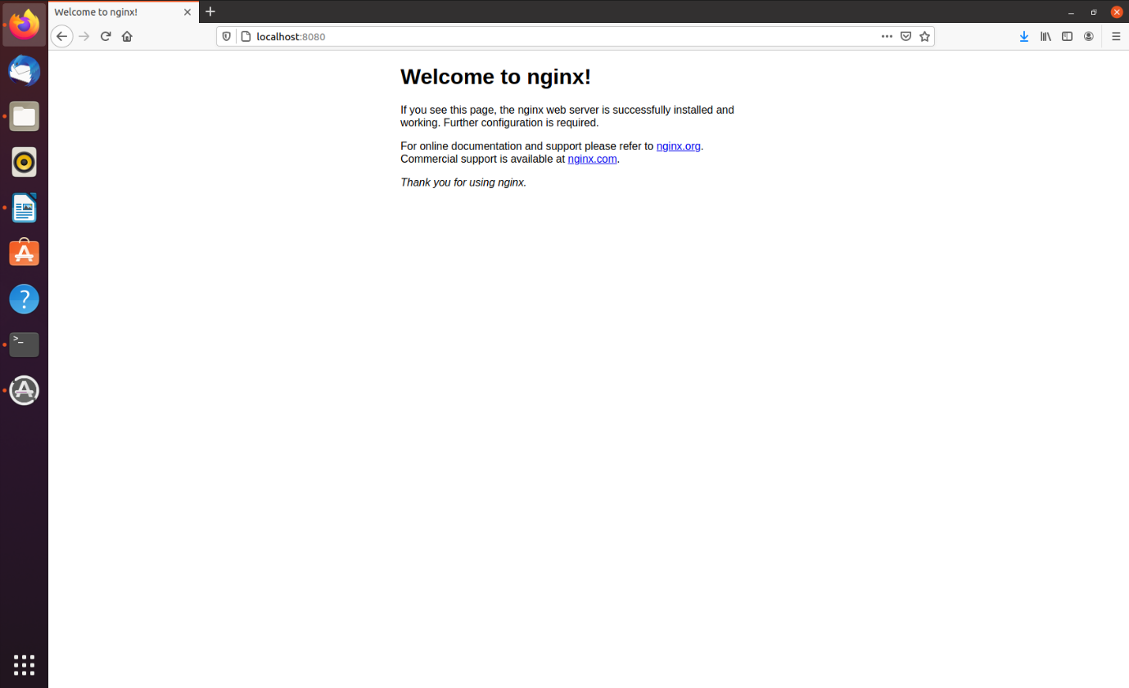

**2b.png**

3.) **Task 3: Create a Kubernetes Deployment and create a Load Balancing Service**

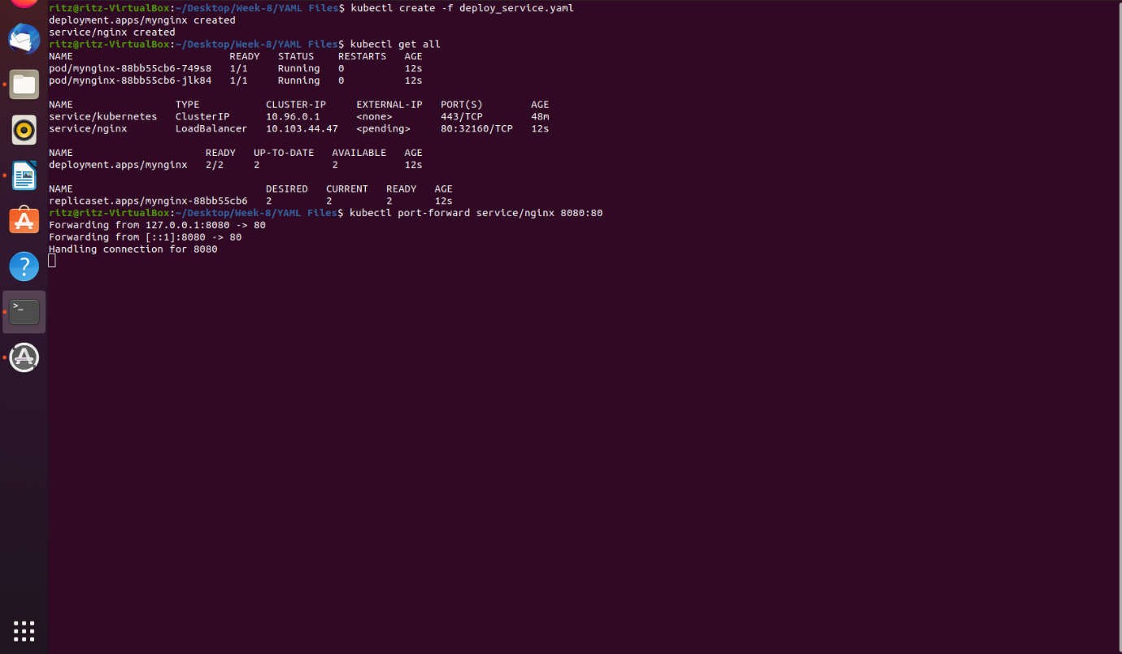

**3a.png**

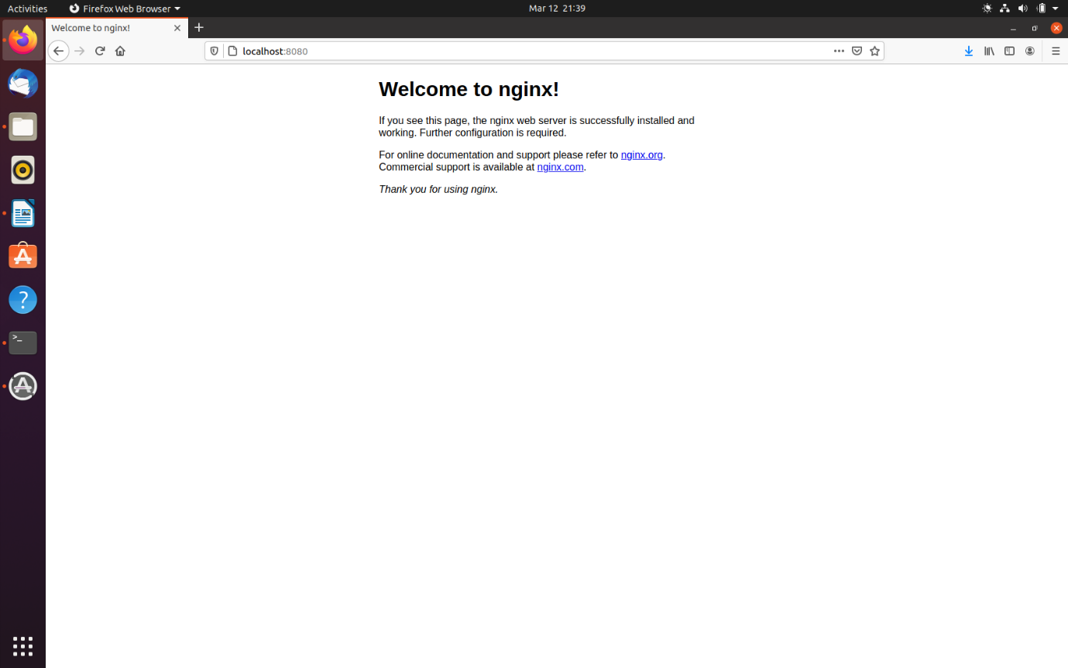

**3b.png**

4.) **Task 4: Scaling deployments**

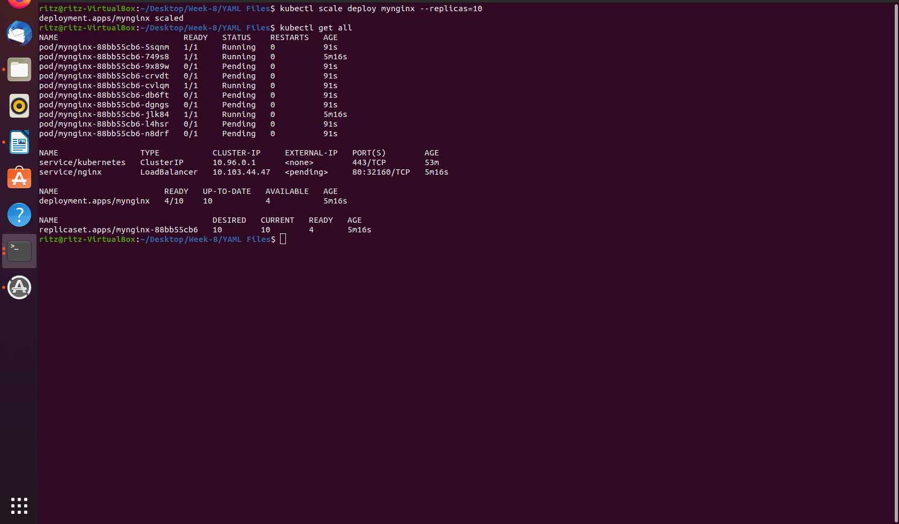

**4a.png**